Encoding an Old Norwegian text in XML : A tutorial

The Legend of Cosdroe and Heraclius in AM 619 4to

By Odd Einar Haugen · Version 1.0 · 7 June 2017
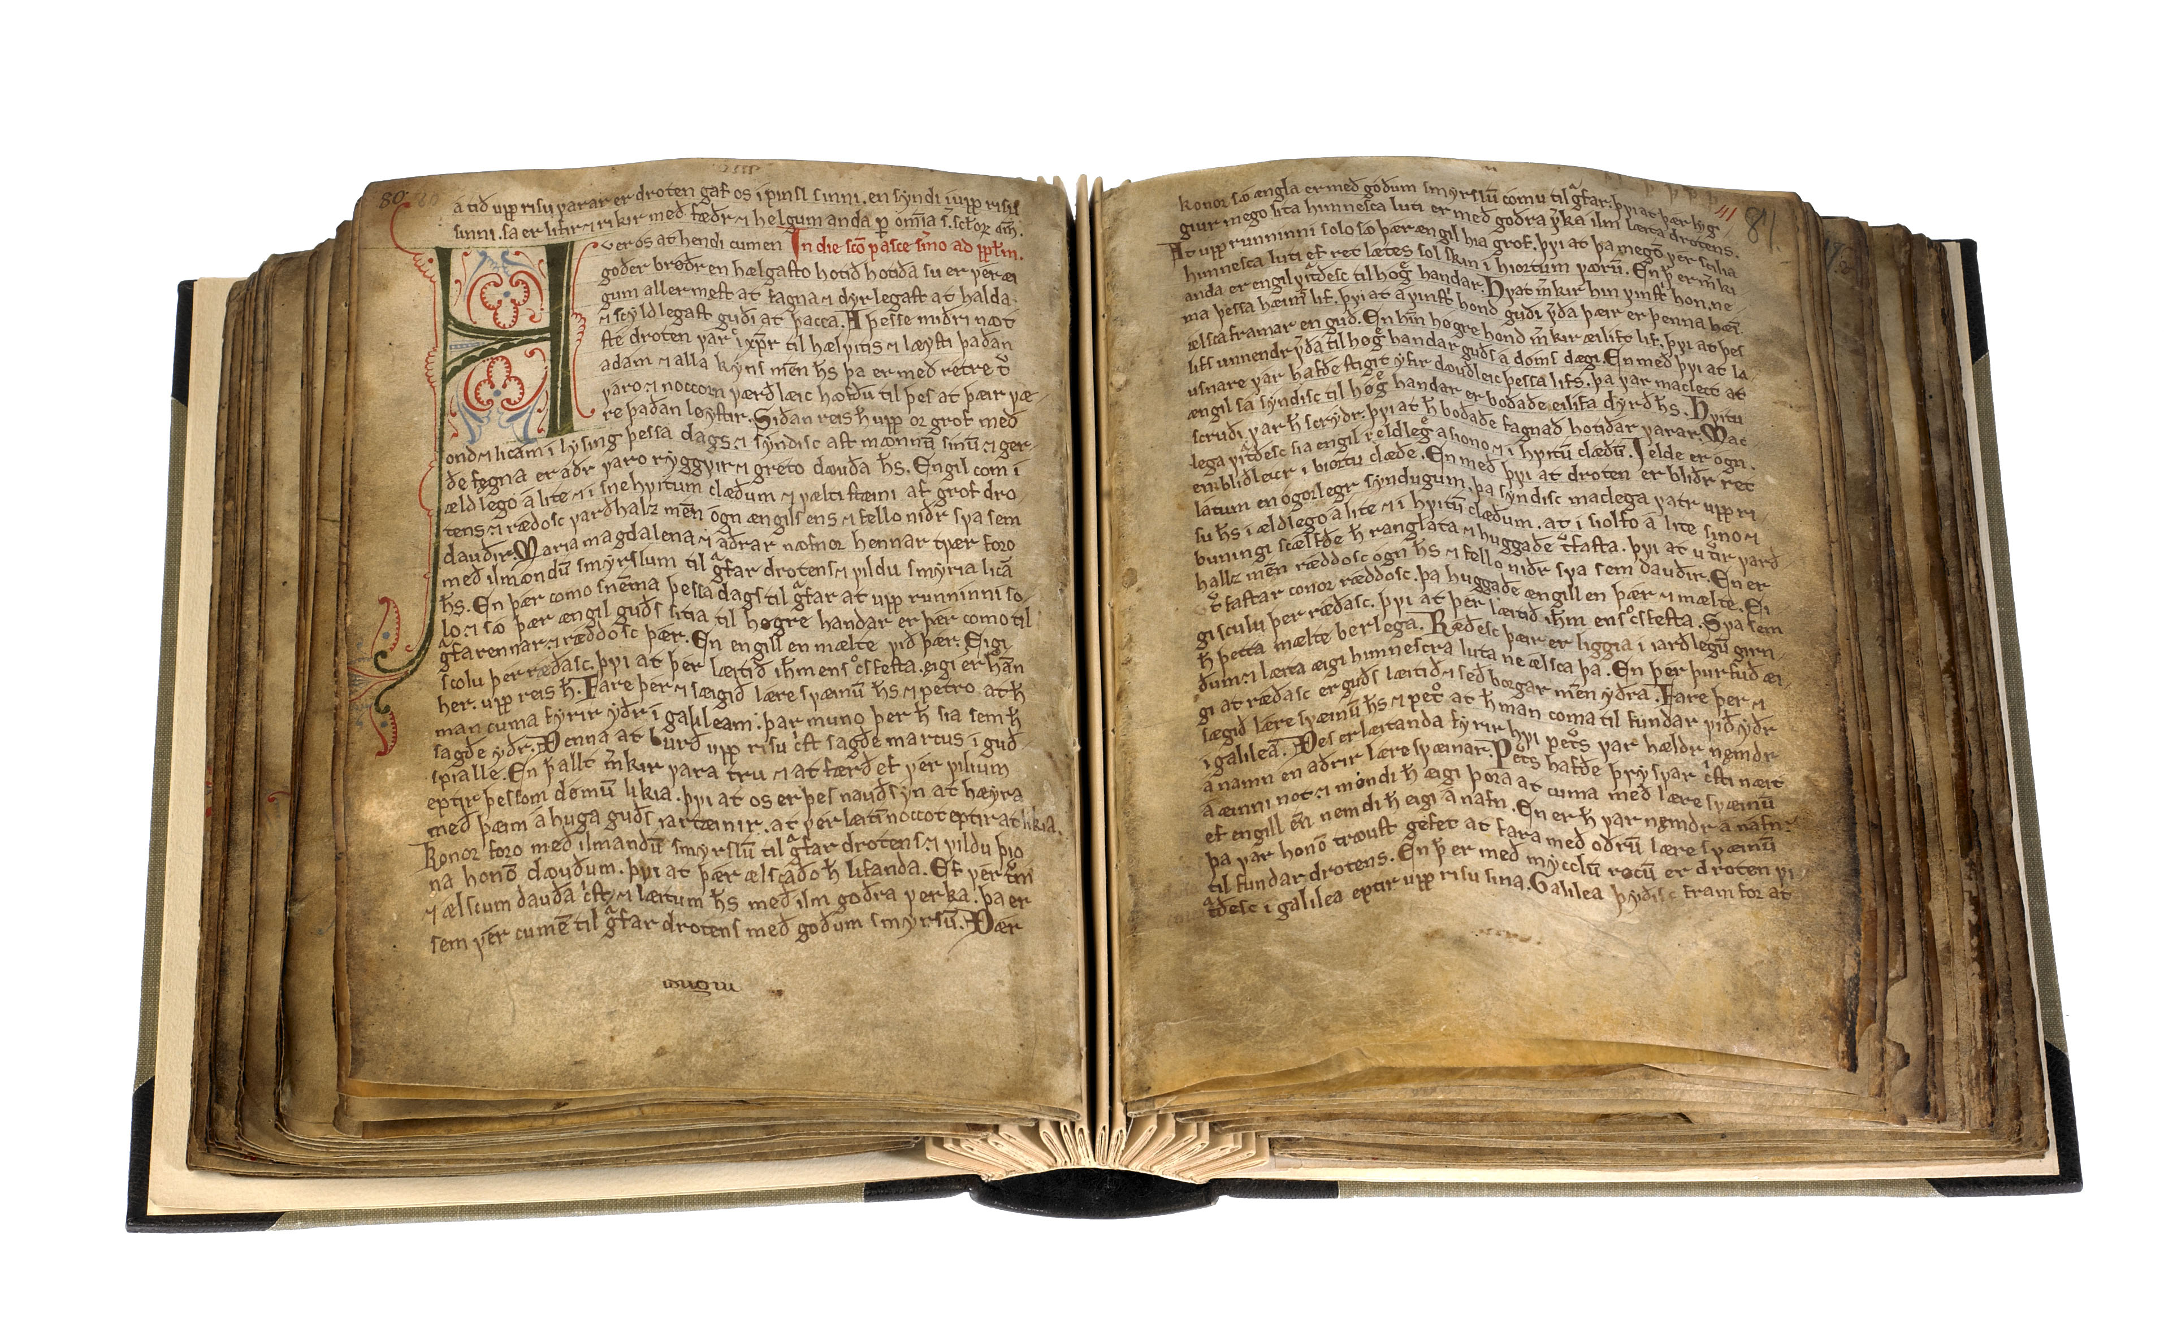

This is an extended version of a tutorial made for a course in text encoding held at the University of Verona, 20–21 April 2017, Edizione Scientifica Digitale. In this extended version, it is hopefully useful for anyone who would like to try encoding a rather simple medieval text on a diplomatic level, i.e. transcribing the text word by word, line by line. Translations of the text into German and Italian are located at the end of the tutorial.

Please note that all files in this PDF tutorial are available from the Tutorial and Samples of the Menota Handbook, v. 3.0, at http://www.menota.org/HB3_index.xml

The text used for this tutorial is the legend of Cosdroe and Heraclius in the Old Norwegian Homily Book. This text is based on a Latin version of the legend, and is in the manuscript entitled In exaltatione sancte crucis ‘On the Exaltation of the Holy Cross’. It appears alongside a number of homilies.

The Old Norwegian Homily Book (shown above) is also referred to as AM 619 4to, meaning that it belongs to the manuscript collection of Árni Magnússon (1663–1730) and is now kept in the collection still carrying his name in Copenhagen, The Arnamagnæan Collection. It is the earliest almost complete Norwegian codex, written in Bergen not long after 1200. The script might be called an early Protogothic type with distinct Insular features, and it clearly testifies to the fact the Early Norwegian script was based on English script of the time, showing a mixture of Insular and Carolingian traits. Unusually, the scribe of AM 619 4to also wrote the rubrics and drew the initials himself, and his hand has also been identified in fragments of Latin liturgical codices.
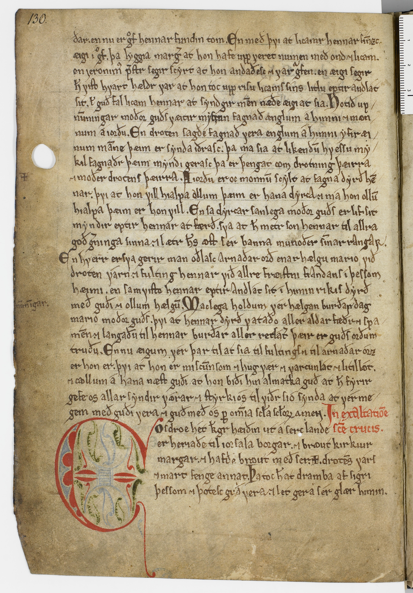

AM 619 4to, fol. 65v

The Legend of Cosdroe and Heraclius begins with the large initial “C” in line 26.

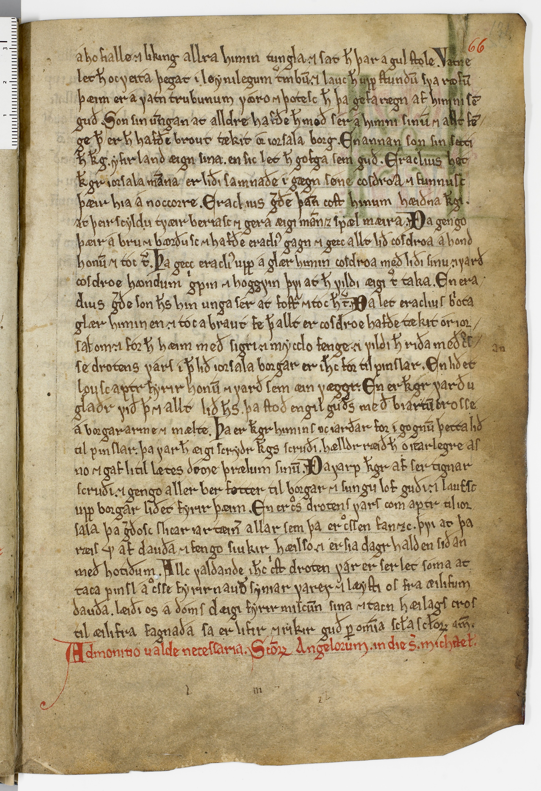

AM 619 4to, fol. 66r

The legend ends in the line immediately above the red rubric in the bottom line.

1. Selecting the XML editor

There are a number of XML editors available. In the Menota project, we recommend using the Oxygen XML Editor. Other editors may be used for the actual transcription, but they may not work as well for the remaining process described here.



The Oxygen editor can be downloaded free of charge for a test period of 30 days. If
you would like to continue using it, there are favourable academic licenses to be had,
cf. https://www.oxygenxml.com/xml_editor.html
An important advantage of Oxygen is that it runs on all major platforms, including Windows, Mac and Linux.

2. Opening a transcription file

For the simplified transcription in this tutorial, a suitable XML file will be needed.
An empty transcription file containing the necessary links can be downloaded from
the S 4 Skeleton XML file: http://www.menota.org/HB3_S1.xml

The file is called etf.xml (meaning “empty transcription file”).

If you would like to set up the file on your own, this is what it should look like:

<?xml version="1.0" encoding="UTF-8"?>
<!DOCTYPE transcription [
<!ENTITY % menotaEntities SYSTEM
'http://www.menota.org/menota-entities.txt'>
%menotaEntities;]>
<transcription
xmlns:xsi="http://www.w3.org/2001/XMLSchema-instance"
xsi:noNamespaceSchemaLocation="http://www.menota.org/handbok_3/samples/
menotaBliX.xsd">
<text>
<div type="text">
<p>
<!-- YOUR TRANSCRIPTION HERE! -->
</p>
</div>
</text>
</transcription>

3. Beginning a simplified transcription

When transcribing the text, you should follow the simple rules set out in section
T 3 Simplified transcription, http://www.menota.org/HB3_T1.xml
Begin by deleting the comment <!-- YOUR TRANSCRIPTION HERE! --> and start the transcription on this line. Do not worry about the number of spaces (or tabulators) anywhere in the file, since in an XML file, a space is always just a single space, whether you have in fact hit the space bar one time or a hundred times between two words.
1. Whether you are using the skeleton XML file or not, remember to have your whole transcription within this structure: <div> <p> ... </p> </div>. There may be more than one <div> within the overarching <div>, and more than one <p> within each <div>. There may also be a <head> in each <div>, preceding all <p> elements.
2. Begin by entering the leaf/page/colum/line number for the text, delimited by colons. Leaf numbers should be given as :1r:, :1v:, :2r:, etc. Sometimes a manuscript has been paginated rather than foliated, in which case page numbers should be given as :1p:, :2p:, :3p:, etc. Column numbers (if there are more than one column) are given as :a: and :b: (etc.) Line numbers are simply given as :1:, :2:, :3:, etc. A manuscript reference like 17ra.9 would then be :17r: :a: :9: (with or without spaces, new lines or the like in between). Note that there should always be white space after a linebreak, except for the case described in section 5 below.
3. Transcribe words on a diplomatic level, as defined in the Menota Handbook ch. 4. Use the space bar (or any amount of white space) between each graphic word in the text.
3.1. Two or more graphic words representing a single lexical word should be connected by a single underline. Decide on a dictionary as a norm. Example: “veiði kona” should be transcribed as “veiði_kona”, and will thus be regarded as an example of the lexical word veiðikona f.
3.2. One graphic word representing two or more lexical words should be divided by a single plus character. Example: “alandi” should be transcribed as “a+landi”, and will thus be regarded as an example of “á” prep. + “landi” (dative of land n.).
4. Abbreviations should be expanded and inserted in round brackets, e.g. “h(ann)”.
5. Lexical words across a linebreak should be transcribed with the line number at the break and no spaces on either side of the line number, e.g. “kon:5:ungr”.
5.1. If there is a hyphen in the manuscript, add this to the word, e.g. “kon-:5:ungr”
5.2. If there is no hyphen, simply transcribe the word without a hypen, e.g. “kon:5:ungr”.
4. Dealing with special characters

While the standard characters in the Latin alphabet should not cause any problems, some of the Medieval Nordic characters may not be as easily accessible. If this happens to be the case, a character entity can be used. These are always opened by an ampersand and closed by a semicolon. Here, entities are used for single characters, but they can in fact be used for several characters, words, phrases, etc. In most XML editors, character entities will be highlighted in a different colour.

The list below should cover all special characters in the specimen from the Old Norwegian Homily Book:

Character Code point Entity
þ 00FE &thorn;
Þ 00DE &THORN;
ð 00F0 &eth;
Ð 00D0 &ETH;

á 00E1 &aacute;
é 00E9 &eacute;
í 00ED &iacute;
ó 00F3 &oacute;

æ 00E6 &aelig;
ǽ 01FD &aeligacute;
ꜵ A735 &aolig;
ę 0119 &eogon;
ǫ 01EB &oogon;
ø 00F8 &oslash;
ǿ 01FF &oslashacute;

ᴍ 1D0D &mscap;
ſ 017F &slong;
ꜱ A731 &sscap;
ꝩ A769 &vins;

The combination of the ‘ao’ ligature and an accent can encoded by a precomposed character in the Private Use Area of the Medieval Unicode Font Initiative:

 EFE3 &aoligacute;

Or it can be encoded by two characters in the Official Unicode area:

ꜵ + ´ =  A735 + 0301 &aolig; + &combacute;

5. Recognising and encoding some important characters

1. The Icelandic þ and ð 2. The long and round s

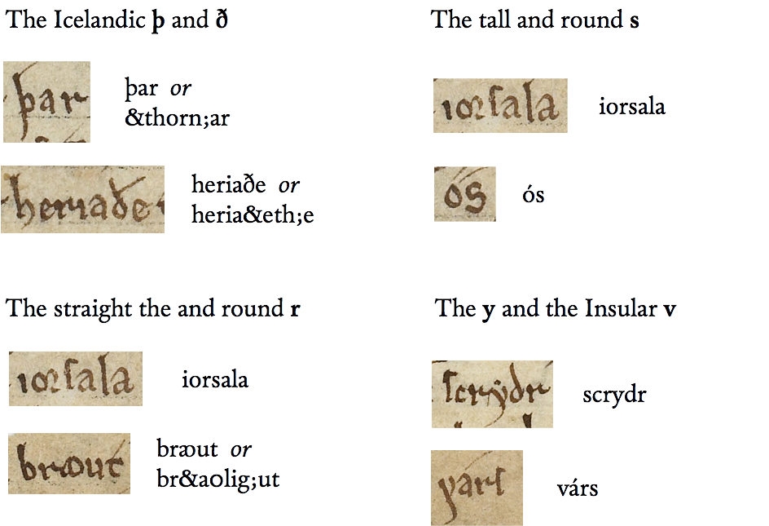

Both types of s can be transcribed as an ordinary s.

3. Regular and round r 4. The y and the Insular v



Both types of r can be transcribed as an ordinary r, and the Insular v can be transcribed as an ordinary v. It is not necessary to transcribe the dot above the y.

5. A few ligatures, i.e. combinations of two characters, usually vowels

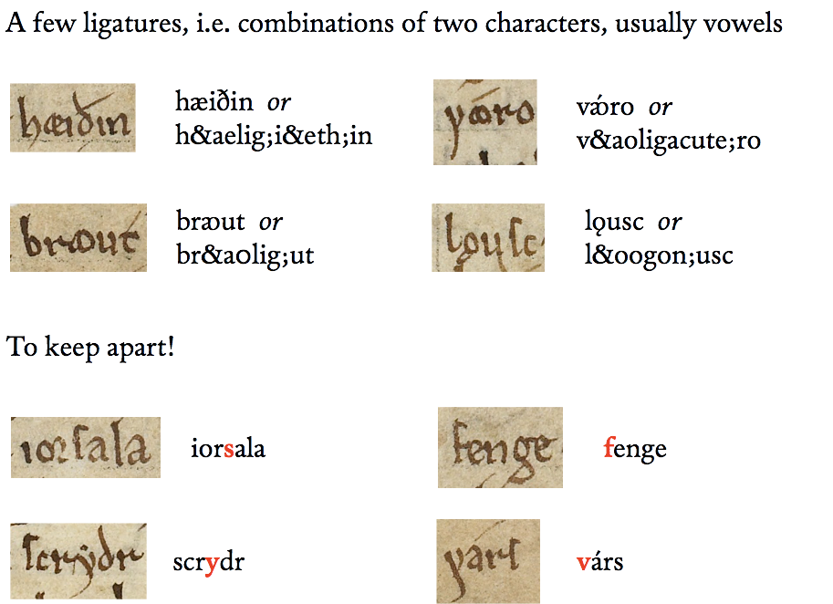

6. To keep apart! The long s can easily be mistaken for an f (and vice versa), and the y can be mistaken for an Insular v – although only the former will be marked by a dot.



6. Understanding and encoding abbreviations

Abbreviations are used in almost all medieval manuscripts. While many Old Icelandic manuscripts have a high number of abbreviations, there are in general fewer in Old Norwegian manuscripts. AM 619 4to uses rather few abbreviation characters. The following list is supposed to be exhaustive in the sense that it contains all types (not all examples) in the text to be transcribed.

1. The horisontal stroke – for m or n (often called the nasal stroke)

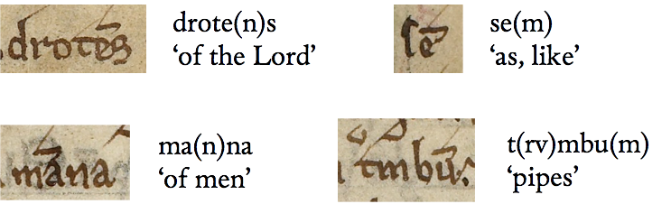

2. The horisontal stroke – for words containing m or n

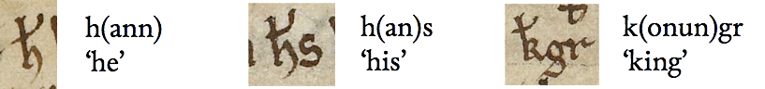

3. Other words abbreviated with a stroke

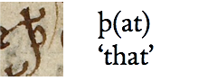

4. The Tironean nota for ok and the Latin sign for us

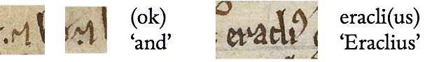

5. The zig-zag sign for er or ir

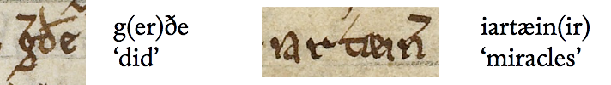

6. Interlinear vowels for r + the vowel: ra, ri, ro, rv

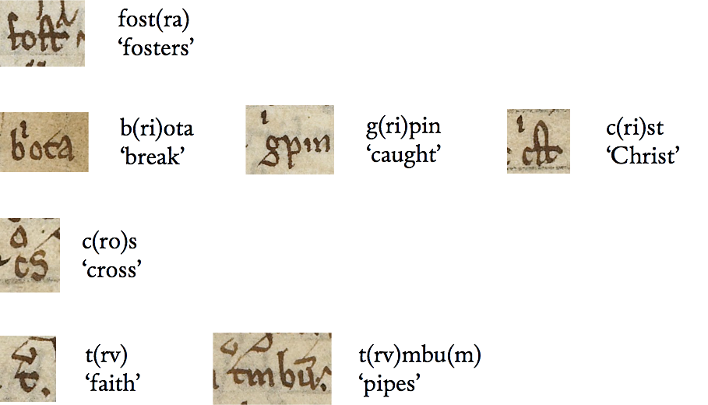

7. Nomina sacra (for Jesus and Christ)

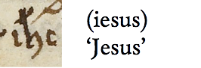

8. Latin words – abbreviated with strokes

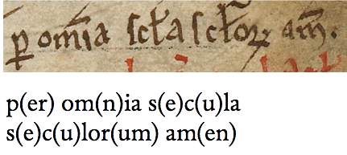

9. Symbols – the Cross of Jerusalem (☩) and the Runic m (ᛉ)

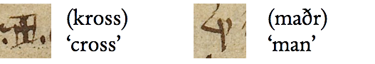

7. Finishing the simplified transcription

Below is the simplified transcription of the text according to the rules set out in section 3 above. You should be able to copy it from the PDF file and copy it into the XML file. However, you should begin by trying to make the transcription yourself! – Note that if you have problems entering special characters, you can use more entities than below. In the transcription below, the initial ‘C’ has been put into a <c> element (for ‘character’) with the attribute type="initial". You might choose to encode it as a simple ‘C’.

<?xml version="1.0" encoding="UTF-8"?>
<!DOCTYPE transcription [
<!ENTITY % menotaEntities SYSTEM
'http://www.menota.org/menota-entities.txt'>
%menotaEntities;
]>
<transcription
xmlns:xsi="http://www.w3.org/2001/XMLSchema-instance"
xsi:noNamespaceSchemaLocation="http://www.menota.org/handbok_3/samples/menotaBliX.xsd">
<text>
<div type="text">
<p>
:65v:
:26: <c type="initial">C</c>Osdroe hét k(onun)gr hæiðin ut á serc_lande
:27: er heriaðe til iorsala_borgar. (ok) br&aolig;ut kirkiur
:28: margar. (ok) hafðe br&aolig;ut með ser (kross) drote(n)s várs
:29: (ok) mart fenge annat. Þa toc h(ann) at dramba af sigri
:30: þessom (ok) þotesc guð vera. (ok) let gera sér glær_himin.
:66r:
:1: á ho_fialle. (ok) liking allra himin_tungla. (ok) sat h(ann) þar á gul_stole. Vatne
:2: let h(ann) oc veita þegat í løynilegu(m) t(rv)mbu(m). (ok) lauc h(ann) upp stundu(m) sva
r&aolig;fu(m)
:3: þæim er á vatn_trubunum v&aoligacute;ro (ok) þotesc h(ann) þa gefa rægn af himni se(m)
:4: guð. Son sin u(n)ngan at alldre hafðe h(ann) með sér á himni sinu(m) (ok) allt
fe(n)-:5:ge þ(at) er h(ann) hafðe brout tækit ór Iorsala_borg. En annan son sin setti
:6: h(ann) k(onun)g. yfir land_æign sina. en sic let h(ann) gofga sem guð. Eraclius hét
:7: k(onun)gr Iorsala_ma(n)na er liði samnaðe í gægn s&oslashacute;ne cosdroa (ok) funnusc
:8: þæir hia á noccorre. Eraclius g(er)ðe þa(n)n cost hinum hæiðna k(onun)gi.
:9: at þeir scyldu tvæir beriasc (ok) gera æigi ma(n)nz_spæl mæira. Ða gengo
:10: þæir á bru (ok) b&aolig;rðusc (ok) hafðe eracli(us) gagn (ok) gecc allt lið cosdroa á hond
:11: honum (ok) tóc t(rv). Þa gecc eracli(us) upp á glær_himin cosdroa með liði sínu. (ok) varð
:12: cosdroe h&aolig;ndum g(ri)pin (ok) hoggvin þvi at h(ann) vildi æigi t(rv) taka. En
era-:13:clius g(er)ðe son h(an)s hin unga sér at fost(ra) (ok) tóc hann t(rv). Ða let eraclius b(ri)ota
:14: glær_himin_en. (ok) tóc a braut fe þ(at) allt er cosdroe hafðe tækit ór
ior-:15:salom. (ok) fór h(ann) hæim með sigri. (ok) mycclo fenge. (ok) vildi h(ann) riða með
cros-:16:se drotens várs í þ(at) lið iorsala_borgar er i(esus) fór til pinslar. En lið_et
:17: l&oogon;usc aptr fyrir honum (ok) varð sem æin væggr. En er k(onun)gr varð
u:18:glaðr við þ(at) (ok) allt lið h(an)s. þa stoð engil guðs með biartu(m) crosse
:19: á borgararme (ok) mælte. Þa er k(onun)gr himins oc iarðar for í gognu(m) þetta lið
:20: til pinslar. þa var h(ann) æigi scrydr k(onun)gs scruði. hælldr ræið h(ann) ó_itarlegre
as:21:no (ok) gaf litil_lætes d&oslashacute;&mscap;e þrælum sinu(m). Ða varp k(onun)gr af sér
tignar:22:scruði. (ok) gengo aller ber_føtter til borgar (ok) sungu lof guði. (ok) laucsc
:23: upp borgar_liðet fyrir þæim. En er c(ro)s drotens vars com aptr til
ior:24:sala þa g(er)ðosc slicar iartæin(ir) allar sem þa er c(ro)ssen fanzc. þvi at þa
:25: ræis (maðr) af dauða (ok) fengo siukir hæilso. (ok) er sia dagr halden sið_an
:26: með hotiðum. Allc valdande I(esus) droten vár er ser let sóma at
:27: taca pinsl á c(ro)sse fyrir nauð_syniar (ok) læysti os fra æilifum
:28: dauða. læiði o&sscap; á dóms_dæigi fyrir miscunn sina (ok) tacn hæilags cros
:29: til æilifra fagnaða sa er lifir (ok)+rikir guð p(er) om(n)ia s(e)c(u)la s(e)c(u)lor(um) am(en).
</p>
</div>
</text>
</transcription>

8. Converting the simplified transcription with a Perl script

There is a price to pay for everything. In order to make the simplified transcription into a full XML file suitable for Menota, you need to convert it. If you follow the procedures specified in T 3.2 of the Tutorial, this will be quickly done. Note that the Perl script, menotaBlitzS.plx, will convert your transcription to an XML file for the Oxygen editor.

The menotaBlitzS script does the following:

1. The document structure is encoded with the elements <pb/> (for pagebreak), <cb/> (for columnbreak, not relevant here, since the text is in a single column) and <lb/> (for linebreak), and they will be complemented with attributes for their number, e.g. n="66r" for the opening of leaf 66 recto, or n="1" for the opening of line 1.
2. All words are put into a <w> element (so that they at a later stage can be annotated for morphology or the like).
3. All punctuation marks are put into a <pc> element.
4. Expanded abbreviations are put into an <ex> element.
5. Compound words are put into a single <w> element,
e.g. serc_lande → <w>serc lande</w>
6. Words written together are put into a <seg> element with the attribute type="nb" (where “nb” means “no break”) and within this into <w> elements,
e.g. a+lande → <seg type="nb"><w>a</><w>lande</w></seg>
7. Hyphenated words are correctly placed within the <w> element, e.g.
ior-:15:salom → <w>ior<c type="hyphen">-</c><lb n="15"/>salom</w>
9. Arriving at the final XML file

After the conversion, the first lines of the XML file should look like this (the initial declarations and the header not included):

<text>
<body>
<div type="text">
<p>
<pb n="65v"/>
<lb n="26"/>
<w><c type="initial">C</c>Osdroe</w>
<w>hét</w>
<w>k<ex>onun</ex>gr</w>
<w>hæiðin</w>
<w>ut</w>
<w>á</w>
<w>serc lande</w>
<lb n="27"/>
<w>er</w>
<w>heriaðe</w>
<w>til</w>
<w>iorsala borgar</w>
<pc>.</pc>
<w><ex>ok</ex></w>
<w>br&aolig;ut</w>
<w>kirkiur</w>
<lb n="28"/>
<w>margar</w>
<pc>.</pc>
<w><ex>ok</ex></w>
<w>hafðe</w>
<w>br&aolig;ut</w>
<w>með</w>
<w>ser</w>
<w><ex>kross</ex></w>
<w>drote<ex>n</ex>s</w>
<w>várs</w>
<lb n="29"/>
<w><ex>ok</ex></w>
<w>mart</w>
<w>fenge</w>
<w>annat</w>
<pc>.</pc>
<w>Þa</w>
<w>toc</w>
<w>h<ex>ann</ex></w>
<w>at</w>
<w>dramba</w>
<w>af</w>
<w>sigri</w>
<lb n="30"/>
<w>þessom</w>
<w><ex>ok</ex></w>
<w>þotesc</w>
<w>guð</w>
<w>vera</w>
<pc>.</pc>
<w><ex>ok</ex></w>
<w>let</w>
<w>gera</w>
<w>sér</w>
<w>glær himin</w>
<pc>.</pc>
<pb n="66r"/>
<lb n="1"/>
<w>á</w>
<w>ho fialle</w>
<pc>.</pc>
<w><ex>ok</ex></w>
<w>liking</w>
<w>allra</w>
<w>himin tungla</w>
<pc>.</pc>
<w><ex>ok</ex></w>
<w>sat</w>
<w>h<ex>ann</ex></w>
<w>þar</w>
<w>á</w>
<w>gul stole</w>
<pc>.</pc>
<w>Vatne</w>
<lb n="2"/>
<w>let</w>
<w>h<ex>ann</ex></w>
<w>oc</w>
<w>veita</w>
<w>þegat</w>
<w>í</w>
<w>løynilegu<ex>m</ex></w>
<w>t<ex>rv</ex>mbu<ex>m</ex></w>
<pc>.</pc>
<w><ex>ok</ex></w>
<w>lauc</w>
<w>h<ex>ann</ex></w>
<w>upp</w>
<w>stundu<ex>m</ex></w>
<w>sva</w>
<lb n="3"/>
<w>þæim</w>
<w>er</w>
<w>á</w>
<w>vatn trubunum</w>
<w>v&aoligacute;ro</w>
<w><ex>ok</ex></w>
<w>þotesc</w>
<w>h<ex>ann</ex></w>
<w>þa</w>
<w>gefa</w>
<w>rægn</w>
<w>af</w>
<w>himni</w>
<w>se<ex>m</ex></w>
<lb n="4"/>
<w>guð</w>
<pc>.</pc>
<w>Son</w>
<w>sin</w>
<w>u<ex>n</ex>ngan</w>
<w>at</w>
<w>alldre</w>
<w>hafðe</w>
<w>h<ex>ann</ex></w>
<w>með</w>
<w>sér</w>
<w>á</w>
<w>himni</w>
<w>sinu<ex>m</ex></w>
<w><ex>ok</ex></w>
<w>allt</w>
<w>fe<ex>n</ex><c type="hyphen">-</c>
<lb n="5"/>ge</w>
<w>þ<ex>at</ex></w>
<w>er</w>
<w>h<ex>ann</ex></w>
<w>hafðe</w>
<w>brout</w>
<w>tækit</w>
<w>ór</w>
<w>Iorsala borg</w>
<pc>.</pc>
. . .
. . .
</p>
</div>
</body>
</text>

Note that indents will vary according to the Pretty Print option in the editor.
In this short text, there is a single <div> and within this a single <p>. One might have added a <head> for the title, and divided the single <div> into three <p>, one for each of the paragraphs shown in the transcriptions in section 11 below.

10. Converting the XML file to a more readable HTML file

When you have arrived at a full XML file suitable for Menota, you might want to make it more readable, first of all for proof reading. This requires an XSLT stylesheet, and the procedure is described in the Tutorial T 4 Making the XML readable, http://www.menota.org/HB3_T1.xml. Depending on the XSLT stylesheets you have been using, the result may look like the following screen shots:

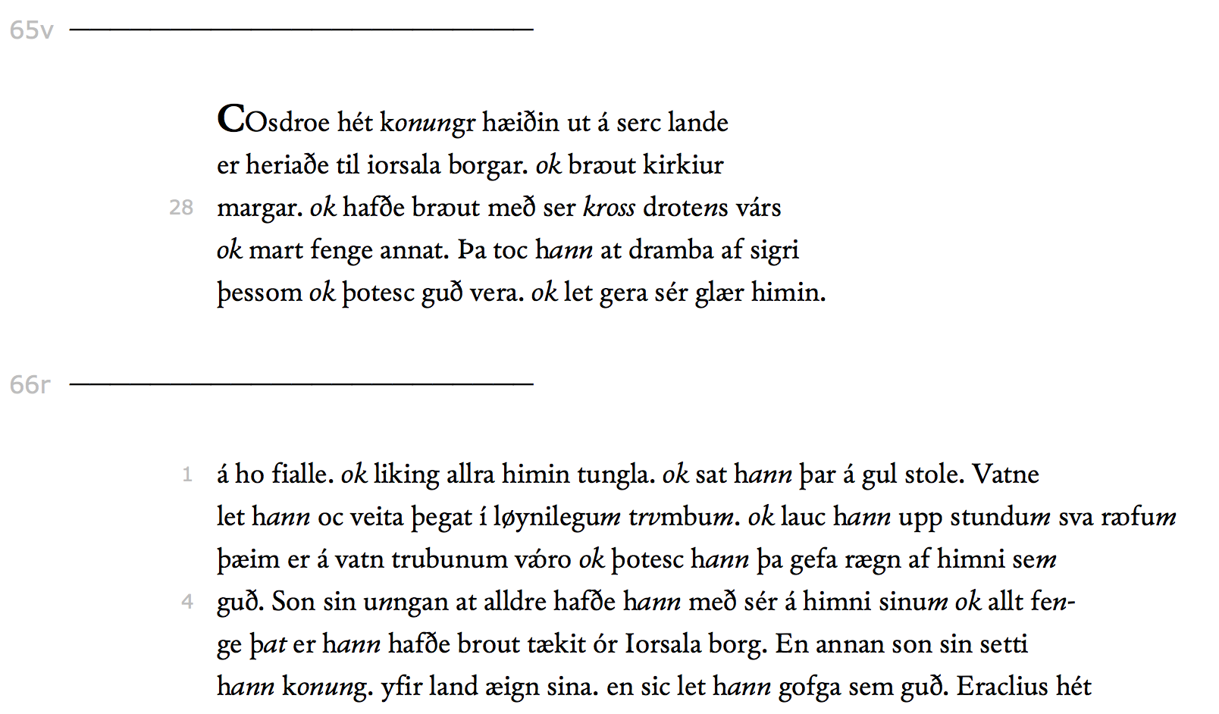

1: Displaying the text line by line and with expanded abbreviations in italics, using
http://www.menota.org/handbok_3/samples/Menota_xslt_Beeke_prl_linebreaks.xsl

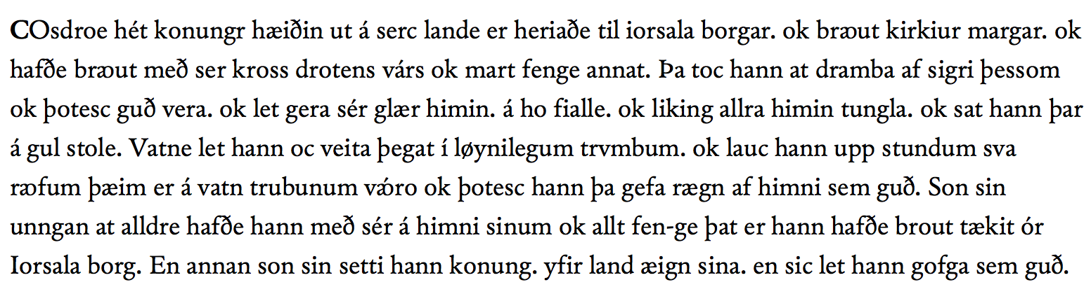

2: Displaying the text in continuous lines, and no indication of abbreviations, using http://www.menota.org/handbok_3/samples/Menota_xslt_Beeke_prl_inline.xsl

11. Examples of transcriptions and translations

On the next pages, you will find a semi-diplomatic transcription of the text, a normalised transcription, and translations into German and Italian. Your own transcription will probably deviate somewhat from the transcriptions below
– but that is part of the fun with editorial work.
In exaltatione sancte crucis

Cosdroe hét konungr hæiðin ut á Serclande, er heriaðe til Iorsalaborgar ok brꜵut kirkiur margar, ok hafðe brꜵut með ser kross drotens várs ok mart fenge annat. Þa toc hann at dramba af sigri þessom ok þotesc guð vera, ok let gera sér glærhimin á hofialle ok liking allra himintungla, ok sat hann þar á gulstole. Vatne let hann oc veita þegat í løynilegum trvmbum, ok lauc hann upp stundum sva rꜵfum þæim er á vatntrubunum vro, ok þotesc hann þa gefa rægn af himni sem guð. Son sin unngan at alldre hafðe hann með sér á himni sinum ok allt fenge þat er hann hafðe brout tækit ór Iorsalaborg. En annan son sin setti hann konung yfir landæign sina, en sic let hann gofga sem guð.
Eraclius hét konungr Iorsalamanna er liði samnaðe í gægn sǿne Cosdroa, ok funnusc þæir hia á noccorre. Eraclius gerðe þann cost hinum hæiðna konungi at þeir scyldu tvæir beriasc ok gera æigi mannzspæl mæira. Þa gengo þæir á bru ok bꜵrðusc, ok hafðe Eraclius gagn ok gecc allt lið Cosdroa á hond honum ok tóc trv. Þa gecc Eraclius upp á glærhimin Cosdroa með liði sínu, ok varð Cosdroe hꜵndum gripin ok hoggvin, þvi at hann vildi æigi trv taka. En Eraclius gerðe son hans hin unga sér at fostra, ok tóc hann trv. Þa let Eraclius briota glærhiminen ok tóc a braut fe þat allt er Cosdroe hafðe tækit ór Iorsalom, ok fór hann hæim með sigri ok mycclo fenge, ok vildi hann riða með crosse drotens várs í þat lið Iorsalaborgar er Iesus fór til pinslar. En liðet lǫusc aptr fyrir honum ok varð sem æin væggr. En er konungr varð uglaðr við þat ok allt lið hans, þa stoð engil guðs með biartum crosse á borgararme ok mælte: “Þa er konungr himins oc iarðar for í gognum þetta lið til pinslar, þa var hann æigi scrydr konungs scruði, hælldr ræið hann óitarlegre asno ok gaf litillætes dóᴍe þrælum sinum.”
Þa varp konungr af sér tignarscruði. ok gengo aller berføtter til borgar ok sungu lof guði, ok laucsc upp borgarliðet fyrir þæim. En er cros drotens vars com aptr til Iorsala, þa gerðosc slicar iartæinir allar sem þa er crossen fanzc, þvi at þa ræis maðr af dauða ok fengo siukir hæilso, ok er sia dagr halden siðan með hotiðum. Allcvaldande Iesus Crist droten vár er ser let sóma at taca pinsl á crosse fyrir nauðsyniar varer ok læysti os fra æilifum dauða, læiði os á dómsdæigi fyrir miscunn sina ok tacn hæilags cros til æilifra fagnaða, sa er lifir ok rikir, guð per omnia secula seculorum amen.

Semi-diplomatic edition by Odd Einar Haugen

In exaltatione sancte crucis

Kósdrói hét konungr heiðinn út á Serklandi, er herjaði til Jórsalaborgar ok braut kirkjur margar, ok hafði braut með sér kross Dróttins várs ok mart fengi annat. Þá tók hann at dramba af sigri þessum ok þóttisk guð vera, ok lét gera sér glerhimin á háfjalli ok líking allra himintungla, ok sat hann þar á gullstóli. Vatni lét hann ok veita þangat í leyniligum trumbum, ok lauk hann upp stundum svá raufum þeim er á vaztrumbunum váru ok þóttisk hann þá gefa regn af himni sem Guð. Son sinn ungan at aldri hafði hann með sér á himni sínum ok allt fengi þat er hann hafði braut tekit ór Jórsalaborg. En annan son sinn setti hann konung yfir landeign sína, en sik lét hann gǫfga sem guð.
Heraklius hét konungr Jórsalamanna, er liði samnaði í gegn søni Kósdróa, ok fundusk þeir hjá á nǫkkurri. Heraklius gerði þann kost hinum heiðna konungi at þeir skyldu tveir berjask, ok gera eigi mannspell meira. Þá gengu þeir á brú ok bǫrðusk, ok hafði Heraklius gagn ok gekk allt lið Kósdróa á hǫnd honum ok tók trú. Þá gekk Heraklius upp á glerhimin Kósdróa með liði sínu, ok varð Kósdrói hǫndum gripinn ok hǫggvinn, því at hann vildi eigi trú taka. En Heraklius gerði son hans hinn unga sér at fóstra, ok tók hann trú. Þá lét Heraklius brjóta glerhimininn, ok tók á braut fé þat allt er Kósdrói hafði tekit ór Jórsǫlum, ok fór hann heim með sigri ok miklu fengi, ok vildi hann ríða með krossi Dróttins várs í þat hlið Jórsalaborgar er Jésús fór til pínslar. En hliðit lauksk aptr fyrir honum ok varð sem einn veggr. En er konungr varð úglaðr við þat ok allt lið hans, þá stóð engill Guðs með bjǫrtum krossi á borgararmi ok mǽlti: “Þá er konungr himins ok jarðar fór í gegnum þetta hlið til pínslar, þá var hann eigi skrýddr konungs skrúði, heldr reið hann úítarligri ǫsnu, ok gaf lítillǽtis dǿmi þrǽlum sínum.”
Þá varp konungr af sér tígnarskrúði, ok gengu allir berfǿttir til borgar ok sungu lof Guði, ok lauksk upp borgarhliðit fyrir þeim. En er kross Dróttins várs kom aptr til Jórsala, þá gerðusk slíkar jartegnir allar sem þá er krossinn fannsk, því at þá reis maðr af dauða, ok fengu sjúkir heilsu, ok er sjá dagr haldinn síðan með hátíðum. Allsvaldandi Jésús Kristr Dróttinn várr, er sér lét sóma at taka pínsl á krossi fyrir nauðsynjar várar ok leysti oss frá eilífum dauða, leiði oss á dómsdegi fyrir miskunn sína ok tákn heilags kross til eilífra fagnaða, sá er lifir ok ríkir, Guð, per omnia secula seculorum. Amen.

Normalised edition by Odd Einar Haugen

In exaltatione sancte crucis

Cosdroe hieß ein heidnischer König draußen in Serkland, der bis Jerusalem auf Beutezug war, und er riss viele Kirchen nieder und nahm das Kreuz Unseres Herrn mit und viele andere Dinge. Durch diesen Sieg begann er hochmütig zu werden und er glaubte Gott zu sein und ließ sich einen Glashimmel auf einem hohen Berg machen und Nachbildungen aller Gestirne, und dort saß er dann auf einem goldenen Stuhl. Er ließ auch Wasser dorthin leiten in verborgenen Rohren, und manchmal öffnete er Löcher in den Wasserrohren und es schien, als würde er es vom Himmel regnen lassen wie Gott. Seinen jungen Sohn hatte er bei sich in seinem Himmel und ebenso all das, was er aus Jerusalem weggenommen hatte. Seinen zweiten Sohn machte er zum König über seine Ländereien und sich selbst ließ er als Gott verehren.
Eraclius hieß ein König der Jerusalemer, der ein Heer gegen den Sohn Cosdroes sammelte, und sie stießen an einem Fluss aufeinander. Eraclius bot dem heidnischen König an, dass sie beide miteinander kämpfen sollten und keine weiteren Menschenleben vernichteten. So gingen sie auf eine Brücke und kämpften miteinander, und Eraclius errang den Sieg und das gesamte Heer Cosdroes unterwarf sich ihm und nahm den Glauben an. Da ging Eraclius mit seinem Heer zum Glashimmel Cosdroes hinauf, und Cosdroe wurde festgenommen und erschlagen, weil er nicht den Glauben anehmen wollte. Aber Eraclius nahm seinen jungen Sohn als Ziehsohn und der nahm den Glauben an. Dann ließ Eraclius den Glashimmel zerbrechen und nahm all den Besitz, den Cosdroe aus Jerusalem weggeschleppt hatte, und er begab sich mit diesem Sieg und reicher Beute nach Hause. Er wollte mit dem Kreuz unseres Herrn durch das Tor der Jerusalemer reiten, durch das Jesus zu seiner Kreuzigung gegangen war. Aber das Tor verschloss sich vor ihm und stand wie eine Wand da. Und als der König und sein ganzes Heer darüber unglücklich wurde, stand ein Engel Gottes mit leuchtendem Kreuz auf der Burgmauer und sagte: Als der König des Himmels und der Erden durch dieses Tor zu seiner Passion zog, da war er nicht in das Gewand eines Königs gekleidet; vielmehr ritt er auf einem niederen Esel und gab seinen Jüngern ein Beispiel der Demut.
Da warf der König sein Ehrengewand von sich und alle gingen barfuß zur Stadt und sangen Gott zu Lob, und da öffnete sich vor ihnen das Stadttor. Aber als das Kreuz unseres Herrn nach Jerusalem zurück kam, da geschahen überall solche Wunder, wo das Kreuz war, denn da erhob sich der Mensch vom Tod, und Kranken wurde Gesundheit gegeben, und dieser Tag wird seitdem als ein Feiertag begangen. Der allmächtige Jesus Christus, unser Herr, der das Leid am Kreuz auf sich nahm wegen unserer Not und uns vom ewigen Tod befreite, führe uns am Tag des Jüngsten Gerichts durch seine Gnade und das Zeichen des heiligen Kreuzes zur ewigen Freude, er, der lebt und herrscht, Gott per omnia secula seculorum. Amen.

Translation into German by Astrid van Nahl
In esaltazione della santa croce

Cosroe era il nome di un re pagano di quella terra chiamata Serkland. Egli fece una spedizione fino a Gerusalemme e là distrusse molte chiese. Egli aveva portato via con sé la croce di Nostro Signore e molto altro bottino. In seguito a questa vittoria cominciò a diventare presuntuoso e credeva di essere Dio. Perciò si fece fare un cielo di vetro su un alto monte e una riproduzione di tutte le stelle, e là si sedette su un trono dorato. Anche l’acqua vi fece portare attraverso condotti nascosti. A volte apriva dei fori nei condotti dell’acqua, e in questo modo sembrava che facesse cadere la pioggia dal cielo, come Dio. Egli aveva con sé nel suo cielo il figlio minore e anche tutto quanto aveva portato da Gerusalemme. Inoltre stabilì l’altro suo figlio come re sui suoi possedimenti, facendosi adorare come Dio.
Eraclio era il nome del re della gente di Gerusalemme, che raccolse un esercito contro il figlio di Cosroe. Essi si scontrarono presso un fiume. Eraclio propose al re pagano di scontrarsi a duello, non aumentando così la perdita di uomini. Allora andarono su un ponte e si batterono: Eraclio ebbe la meglio e l’intero esercito di Cosroe si sottomise a lui e ricevette la fede. Quindi Eraclio salì al cielo di vetro di Cosroe con il suo esercito, e qui Cosroe fu imprigionato e ucciso, poiché non voleva ricevere la fede. Poi Eraclio prese come figlio adottivo il figlio più giovane di Cosroe, ed egli ricevette la fede. Quindi Eraclio fece distruggere il cielo di vetro e portò con sé tutte le ricchezze che Cosroe aveva portato via da Gerusalemme. Fece ritorno a casa vittorioso e con un grande bottino, e volle attraversare a cavallo, con la croce del Signore, la porta che Gesù attraversò verso il supplizio. Ma la porta si chiuse davanti a lui e divenne come una parete. E quando il re si rattristò per questo, e con lui tutto l’esercito, sul muro di cinta apparve un angelo del Signore, con una croce splendente, e disse: “Quando il sovrano del cielo e della terra attraversò questa porta sulla via verso il supplizio, egli non indossava abiti di re ma sedeva su un semplice asino, dando esempio di umiltà ai suoi discepoli.”
Allora il re gettò via i suoi sontuosi abiti, e tutti si incamminarono scalzi verso la città, cantando lodi a Dio, e la porta si aprì davanti a loro. E quando la croce di Nostro Signore ritornò a Gerusalemme, accaddero tutti gli stessi miracoli di quando era là, poiché allora i morti resuscitavano, e i malati riacquistavano la salute. E da quel momento questo giorno viene considerato giorno di festa. L’onnipotente Gesù Cristo Nostro Signore, che prese su di sé il dolore sulla croce per causa nostra e che ci liberò dalla morte eterna, ci conduca al giorno del giudizio con la sua grazia e con il segno della santa croce alla gioia eterna, Dio, colui che vive e regna per omnia secula seculorum. Amen.

Translation into Italian by Massimiliano Bampi

12. Resources

1 The Menota Handbook v. 3.0
http://www.menota.org/HB3_index.xml

Please note that this version is still on the beta stage. The Tutorial and Samples
at the end should be working, but they may be changed in the coming months
(although probably not dramatically).

2 The Medieval Unicode Font Initiative
For more entities, please see the MUFI character recommendation, v. 4.0,
Alphabetical order, which can be downloaded free of charge at https://bora.uib.no/handle/1956/10699

You can also download MUFI compatible fonts free of charge from this site.
Just follow the link in the section Mufi font page.

3 Annotation of morphology and syntax
While this leaflet does not discuss annotation of morphology and syntax, the fact that the converted text has placed all words in <w> elements means that it is annotation-ready. For an introduction to annotation of Old Norwegian, see these guidelines:

https://bells.uib.no/bells/issue/view/157 (Norwegian text) https://bells.uib.no/bells/issue/view/158 (English text)

